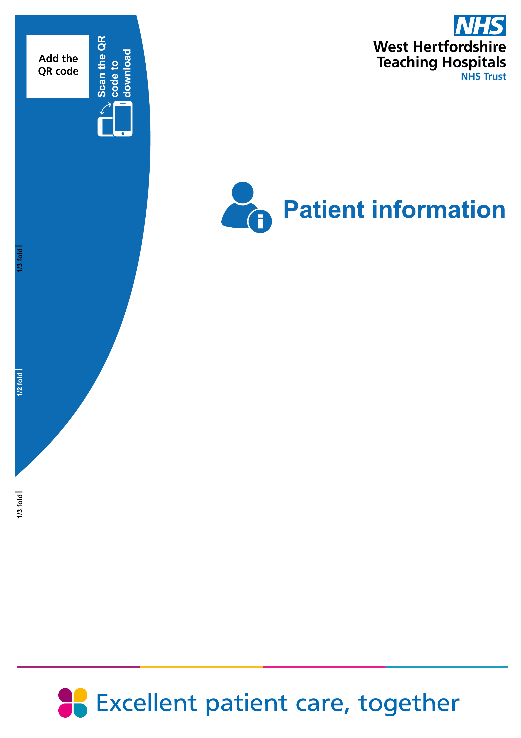

Managing Falls Risk and Bed Rail Safety during your hospital stay
for patients, relatives and carers

Falls Risk and Bed Rail Safety
Introduction
This information will help you to reduce the risk of falling during your stay in hospital. Just like in general life, in hospital it is not possible to prevent all falls. However, by putting in different measures and working together we can reduce the risk of falls happening. If you have any questions or concerns, please speak to the staff member in charge of your care.
Reasons why you may be at risk of having a fall
- You have had a fall before
  - You have difficulty with your walking, balance or you have muscle weakness
  - You have spent a long time in bed, not moving
  - You are worried or anxious about falling
  - You have a problem with your eyesight
  - You are unwell.
What can I do:
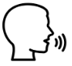
Make staff aware if you have had any falls in the last year and if you use anything at home to reduce the risk of falls - we may be able to use these measures in hospital.


Please do not mobilise on your own if you feel you are unable to or have been advised not to - use your call button for assistance especially if you need help going to the toilet.

Be familiar with your surroundings. Ask for clutter to be moved if your path isn't clear, and report any spillages, trailing wires or cables.

What should I be aware of while in the ward?


You should keep everything you need in easy reach - call button, glasses, walking aid, table with drinks, etc. It is important to drink regularly and eat well.

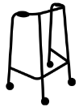
Use your usual walking aid unless advised: otherwise, keep it close by. Never lean on hospital furniture as it is often on wheels.


When getting up from lying or sitting, get up slowly making sure you feel steady before walking. If you feel dizzy please stop and sit down and let the nursing staff know.


Some medicines may increase your risk of falling especially medicines related to anxiety, depression and sleeping tablets. The doctor can review the medication and make adjustments if needed.

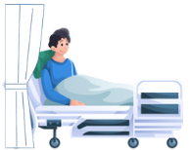

Keep your bedside curtains open as nursing staff need to be able to see patients easily.

What should I wear in the ward


Make sure your shoes or slippers fit well, grip well, cannot fall off and provide support around your heel. If you don’t have any suitable footwear the ward can supply you with anti-slip socks.
If you are required to wear anti-embolic stockings continue to wear your own shoes or anti-slip socks as the anti-embolic stockings do not provide any grip.
We encourage you to wear your own clothes where possible but make sure they are not too long or loose as they could be a trip hazard.

What should I bring to the ward:

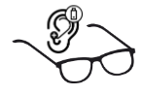
If you normally wear glasses or hearing aids, please have these with you or have a family member bring them in. Always wear your glasses or hearing aids if you need them to avoid falls. Ensure that your glasses are clean. Let the staff know if you are having trouble seeing your hearing.

What can I do to help my recovery?
- Get dressed and try to sit out of bed
- Try to keep occupied by reading, doing puzzles or listening to music
- If you can, walk to the toilet. Please use your walking aid and ask for assistance if you need it.
- Do some regular physical activity - if you are able to stand up at least once every hour, as sitting for long periods slows down recovery.
- If you can, sit out in your chair for your meals / snacks.

What are bed rails?
Bed rails (sometimes called cot sides) are rails attached to the side of a hospital bed. They can be raised or lowered.

Why might bed rails be used?
Bed rails may be used to:
- Help prevent you from accidentally rolling out of bed
- Provide support when turning or moving in bed
- Help you feel safer if you request them
- Help keep you safe when the bed is being moved or during transport within the hospital
- Bed rails are not used routinely and are not suitable for everyone.

What are the risks?
Although bed rails can help some people, they may also cause harm in certain situations:
- Some patients may try to climb over them and fall
- Arms, legs or other body parts may become trapped which can lead to significant harm
- They may cause distress or confusion for some people
People who are confused, restless, or unsteady on their feet may be at higher risk.

How is the decision made?
Healthcare staff will:
- Carry out an individual assessment
- Consider the patient’s wishes whenever possible
- Ensure bed rails are not used as a form of restraint
- Review regularly whether bed rails are needed
Families and carers are welcome to ask questions or raise concerns.

Alternatives to bed rails
Other ways to reduce the risk of falls include:
- Lowering the bed
- In some situations, a floor level bed may be indicated
- Regular staff checks
- Keeping the call bell and personal items within reach

Advice for relatives and carers
Please let nursing staff know if you are concerned about your relative’s risk of falls or wish to discuss the use of bed rails.
Let nursing staff know if you are concerned that your relative has become more confused or is not themselves.
Please take home any items they do not need in the ward to reduce clutter. Before you leave, please check that they have everything they need in reach and the space is clear of obstacles.
When you are leaving, please let the nursing staff know if any adjustments are needed to minimise risk of falls.

Please remember
All these measures are designed to minimise the risk of falling whilst in hospital. However, we cannot restrain patients or deprive them of their liberty, unless deprivation of liberty safeguards are in place. We will always adhere to patients’ wishes, or act in their best interests if they are unable to express their wishes.
Some patients still fall even if we have put all appropriate measures in place. By working together with patients, relatives, and carers we aim to minimise the risk of falls. So please tell us if you have any concerns about yourself, or your relative, we are here to help.

How to contact us

Harm Free Care Team
﻿Watford General Hospital
Vicarage Road
Watford
Hertfordshire WD18 0HB
Tel: 01923 244366 (ext: 7722)
Hospital switchboard: 01923 244366

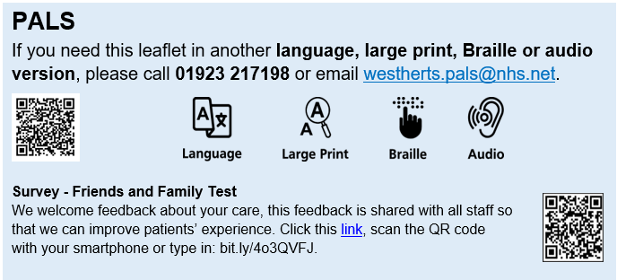

Author | Lisa Selvarajah
Department | Harm Free Care
Ratified / review date | May 2026 / May 2029
ID number | 61/ 2519/V2

