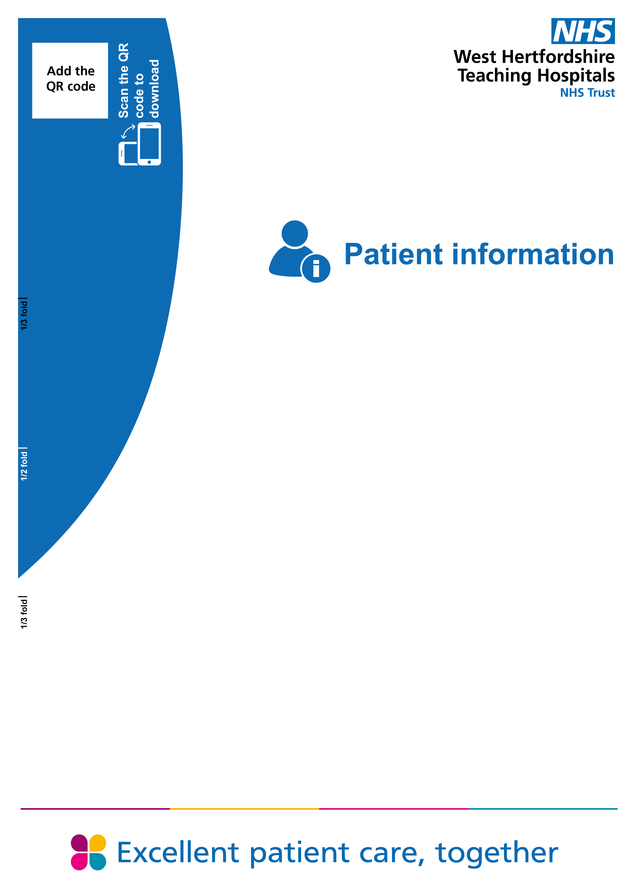

Positive Oral
Food Challenge


Positive Oral Food Challenge
What is a positive food challenge?
A positive challenge means that your child had an allergic reaction during the challenge or observation period following the challenge.
Your child should continue to strictly avoid the food they reacted to during, or after, the challenge.
The nurse caring for your child or the Allergy Nurse will go through your child’s Allergy Action Plan to ensure you feel comfortable managing any allergic reactions.
Please ensure your child refrains from exercise, strenuous play and activities for the rest of the day as this may induce an allergic reaction.
Your child should have their emergency medications available at all times, even when coming into hospital. If an adrenaline pen was used to treat a severe reaction, a new pen will be dispensed before your child is discharged.
It is normal to feel disappointed after experiencing a reaction during a food challenge. It can also be a valuable experience in helping you and your child recognising symptoms of an allergic reaction.
For parents it is important to encourage your child to talk about their experience. Please do not use word ‘fail’ in front of your child when talking about food challenge outcome, but praise your child for participating.
It is also possible that your child will experience increased worry about food challenge after an allergic reaction. This is normal, and most patients feel better in few days.
Your child should strictly continue to avoid the food implicated.
Please unsure that you have an up-to-date Allergy Action Plan and emergency medication available at all times.
Your child should be able to go to school, the next day, following a positive food challenge.
Your child’s consultant will be informed with the outcome of the challenge.
Further information
Contact information for other organisations that can help.

Useful websites
Auto injector training  www.epipen.co.uk  www.jext.co.uk  www.anaphylaxis.org.uk | Allergy UK  www.allergyuk.org  Spare pens in school  www.sparepensinschools.uk
Consultants’ secretaries
Watford General Hospital: 01923 217248
Hemel Hempstead Hospital: 01442 287135

Safari Day Unit  Watford General Hospital  60 Vicarage Road  Watford  Hertfordshire WD18 0HB  Hospital switchboard: 01923 244366 | Children’s Outpatients  ﻿Hemel Hempstead Hospital  Hillfield Road  Hemel Hempstead  Hertfordshire HP2 4AD  Hospital switchboard: 01442 213141
PALS
If you need this leaflet in another language, large print, Braille or audio version, please call 01923 217198 or email westherts.pals@nhs.net.



Survey - Friends and Family Test
We welcome feedback about your care, this feedback is shared with all staff so
that we can improve patients’ experience. Click this link, scan the QR code
with your smartphone or type in: bit.ly/4o3QVFJ.



Author | Dr Ashley Reece
Department | Paediatrics
Ratified / review date | August 2025 / August 2028
ID number | 40/2466/V3

