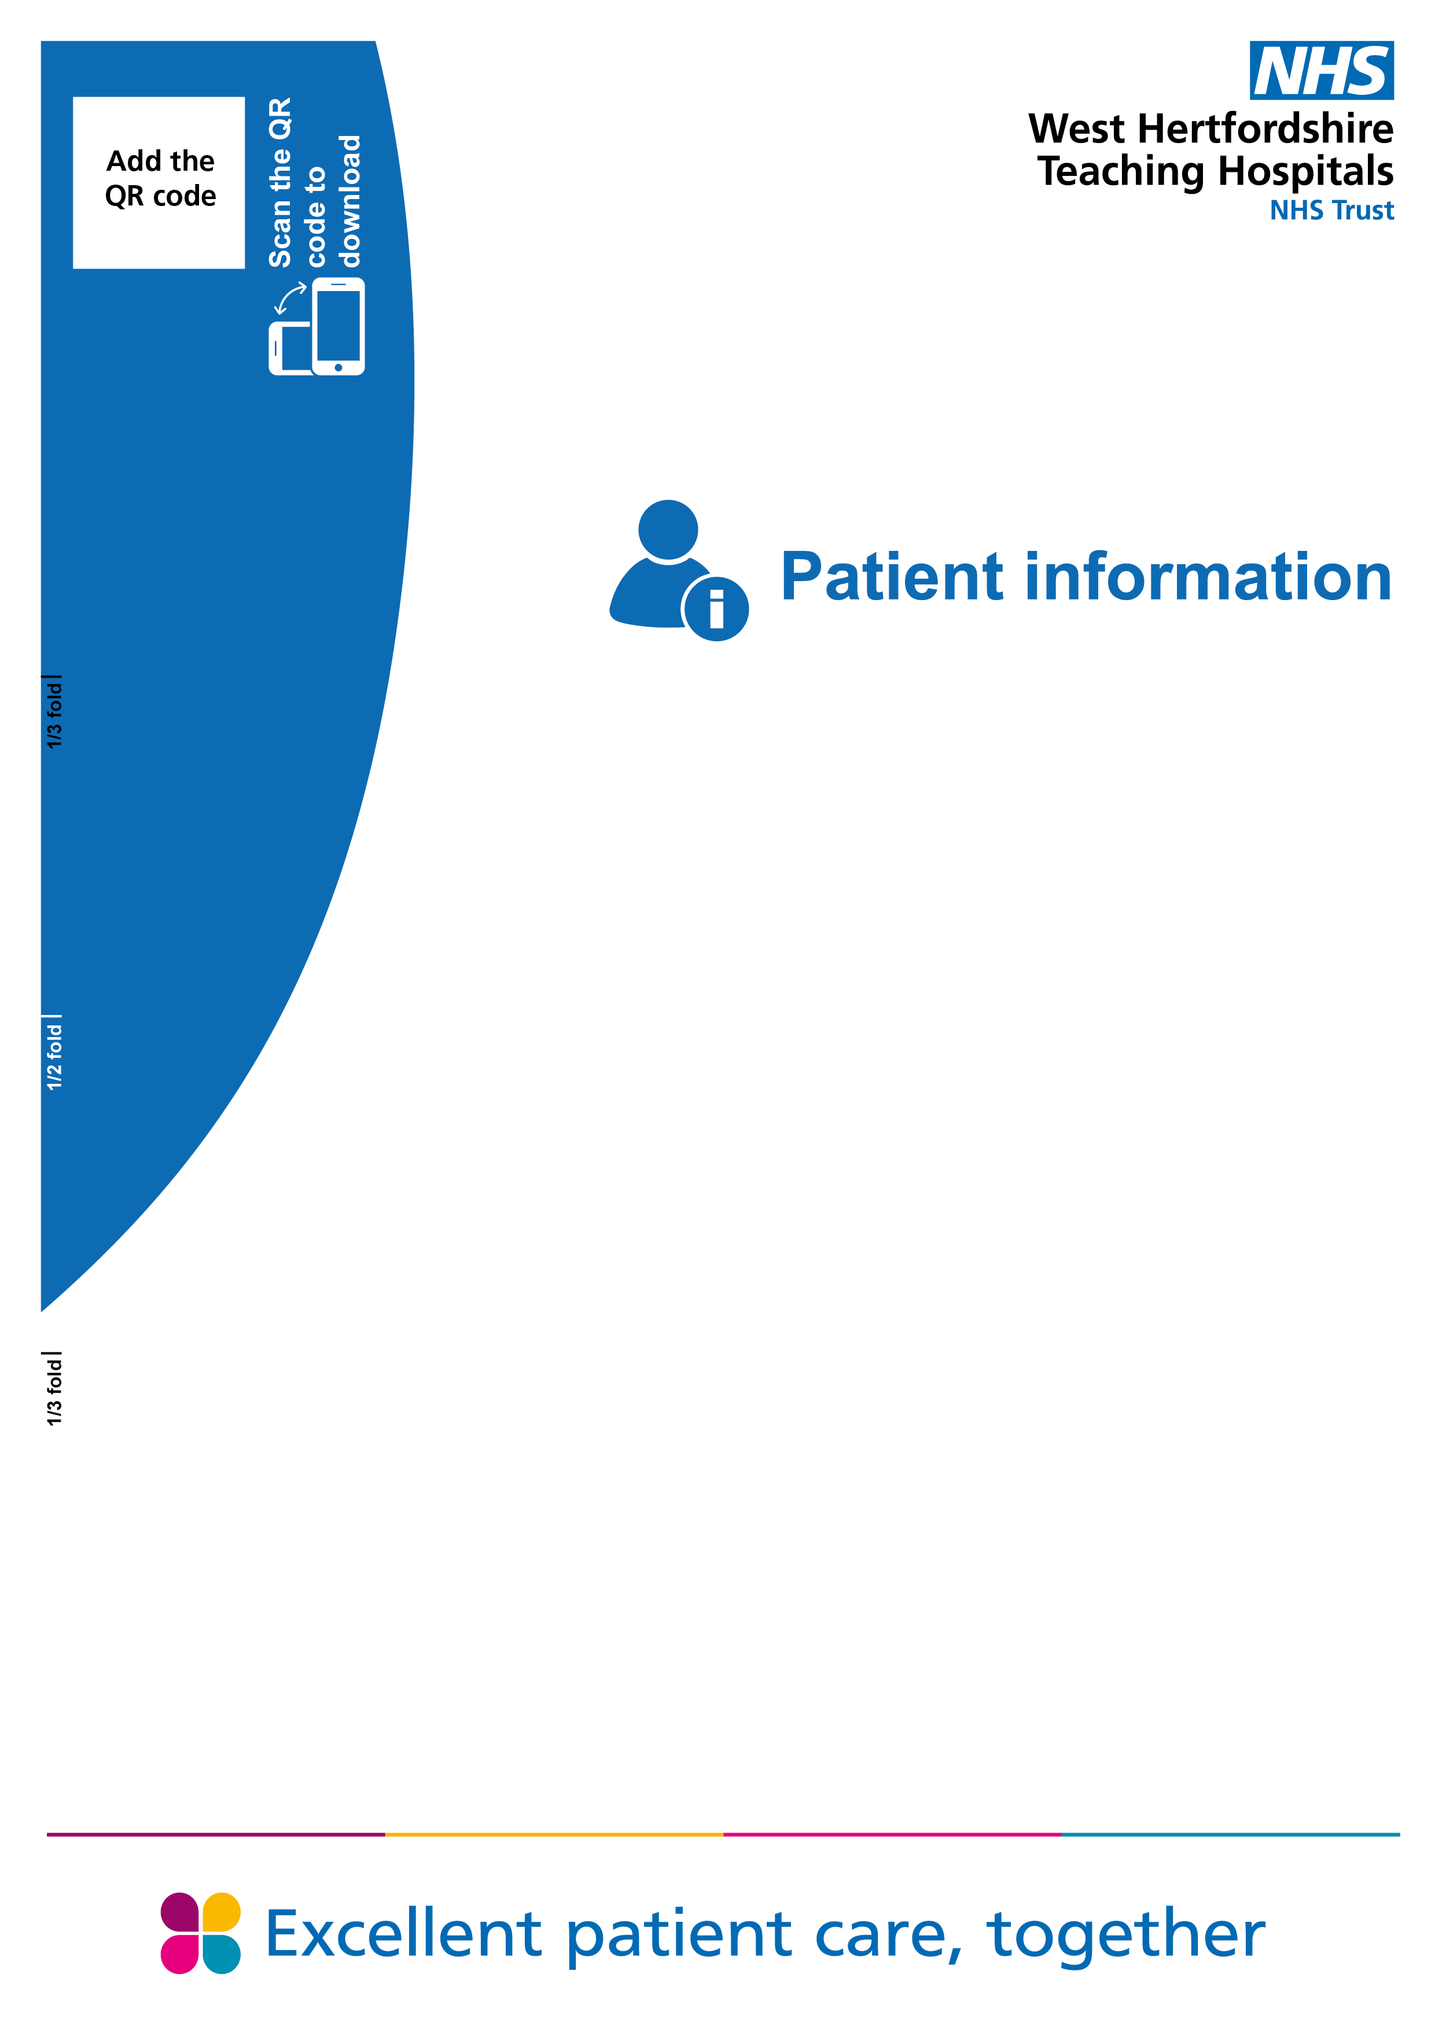

Living with
Dementia and Falls

Living with Dementia and Falls

Falls and Dementia
Falls happen more often as people age, with up to 30% of older people falling each year. The causes of falls can be complicated. Having more than one medical condition, being on lots of medications, and new illnesses such as infections can all add together to increase peoples risk of falling over.
Living with dementia can increase the risk of falls with up to 60% of people living with dementia falling each year.
Falls in Hospital
Being in hospital is a difficult time for people living with dementia.
The hospital environment can be very difficult for them to find their way around. It is easy for them to lose their way, get frustrated and lose confidence.
Falls do happen in the hospital setting. The hospital team will risk assess for any medical, strength, balance and behavioural issues that may contribute to an increased risk of falls in hospital.
The ward teams try to manage the risks that make people more likely to fall, but risk can never be completely eliminated.
What actions may be taken?
It is important to try to maintain people’s mobility in hospital, if people weaken, they will be more at risk of falling over.
Balancing a person’s freedom to move around as and when they want to and their risk of falling over can be very difficult.
Medications are carefully considered and added or removed with caution.
Patients may be moved to areas of the ward where they can be more easily observed by staff.
Walking aids (if required) should be close to hand. It is best if people can wear their own footwear (good slippers or shoes) or temporary hospital non-slip socks.
Further actions may be needed for people most at risk of falls
It is not unusual for people living with dementia who are unsteady on their feet to lack awareness about their risk of falling. This can make it difficult to prevent them from falling when they are being cared for in the unfamiliar environment in the hospital.
These people will need additional actions such as -
Low beds with no rails up may be used to prevent climbing out of bed and falling from a height. Crash mats may be placed to the side of the bed. Sometimes the bed might also be placed against a wall so only one side is a risk. These all can help to reduce the risk of injury from a fall out of bed.
Increased supervision may be put in place. This may include an increase in the number of nurses in the area or in some cases one to one care.
Walking aids will be available but despite reminders and prompts these can often be forgotten or abandoned.

Increase in risk may also occur at times of agitation or distress, or if the hospital stay is further complicated by delirium.
The hospital team will work to reduce the risk of falls and injuries from falls, but this risk cannot be reduced to zero and so falls and injuries do sadly still occur.
Should a fall occur, next of kin will be informed, the patient will be examined by a doctor for any injuries, and if X-rays or tests are needed, they will be carried out as soon as possible. The risk assessment will be reviewed by the ward team to try to prevent a further fall.
If walking aids are no longer needed, please contact the department about how to return them

Further information
Information on who to contact, ie web sites / telephone numbers of other departments / organisations which may be of help.

Dementia UK: https://www.dementiauk.org/

Alzheimers Society: https://www.alzheimers.org.uk/

How to contact us

Inpatient Therapies
Watford General Hospital
West Hertfordshire Hospitals NHS Trust
Vicarage Road
Watford WD18 0HB
Tel: 01923 217271
PALS
If you need this leaflet in another language, large print, Braille or audio version, please call 01923 217198 or email westherts.pals@nhs.net.



Concerns, complaints or suggestions
If you are unhappy with your experience or would like to give feedback, please contact our Patient Advice and Liaison Service (PALS). PALS is available to patients, relatives, carers and friends to raise concerns.

For more information, please scan the QR code or visit our website.

Author | Adrian Vyse
Department | Inpatient Physiotherapy
Ratified / review date | August 2024 / August 2027
ID number | 54-2281-V2

