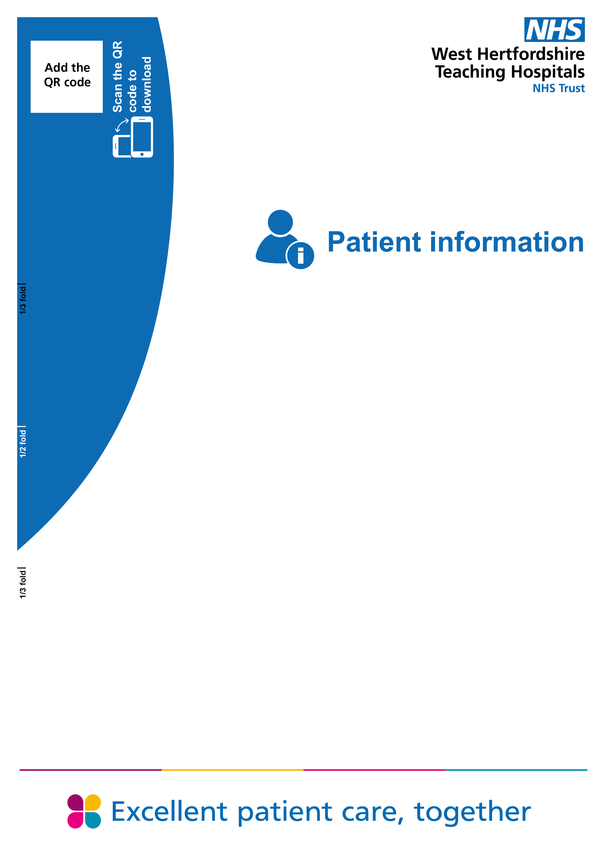

Heart Failure
Guidance on looking after yourself at home

Heart Failure
Guidance on looking after yourself at home

Heart Failure
How to look after yourself

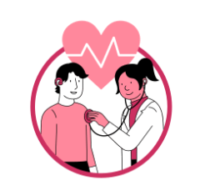 | Did you know?  About 1 in 4 patients with heart failure return to hospital within a month of leaving – but there are things you can do for yourself.  This leaflet gives you the most important steps to stay well.

When to seek help
There are times you should not wait and should ask for help. Please contact your heart failure team immediately if you notice any of the following:
- Worsening breathlessness or swelling
- Difficulty breathing
- Exhaustion with routine activities
- Weight gain of 3kg over a few days with swelling

What to do at home

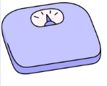 | - Monitor your weight  Check your weight at the same time each day. Contact your healthcare provider if your weight is increasing rapidly or you notice increasing swelling of your legs – this is a sign of your heart failure getting worse.

- Restrict salt intake  This is the most important dietary change to make. Sodium causes your body to retain water which makes your heart work harder. Controlling salt intake will have a big effect on your life and symptoms!  Check the food labels – aim for products with less than 140mg of sodium per serving.  Refer to the leaflet provided for examples of high and low salt foods. | Examples of food with  “hidden salt”  - Bread and cereals  - Canned food including soups  - Readymade food and takeaway  - Processed meats and cheeses  - Sauces  - Crisps and snacks  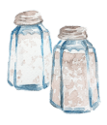

 | - Control your fluids  Adhere to your fluid restriction plan – fluids include things like tea, coffee and soup.

 | Stay active and involve your loved ones.  You are in control of your heart failure.

How to contact us

Heart Failure and Arrhythmia Nurses Speciality Service
﻿Watford General Hospital
Vicarage Road
Watford
Hertfordshire WD18 0HB
Tel: 01923 436502
Hospital switchboard: 01923 244366

PALS
If you need this leaflet in another language, large print, Braille or audio version, please call 01923 217198 or email westherts.pals@nhs.net.



Concerns, complaints or suggestions
If you are unhappy with your experience or would like to give feedback, please contact our Patient Advice and Liaison Service (PALS). PALS is available to patients, relatives, carers and friends to raise concerns.

For more information, please scan the QR code or visit our website.


Survey - Friends and Family Test
We welcome feedback about your care, this feedback is shared with all staff we can improve patients’ experience. Click this link or use the QR code with your smartphone.
Department | Cardiology
Ratified / review date | August 2025 / August 2028
ID number

