Finance Report Month 3 (June) 2010/11 Agenda Item 99/10

Key Financial Indicators

 | Year to Date (Month 3) |  | Page
 |  | RAG rating compared to plan
Financial performance | Deficit against plan of £1.5m | R | 2
Monitor Financial Risk Rating | 2 | R | 9
CIP performance | £2.8m delivered; £0.9 behind plan | R | 3
Liquidity (Net Current Liabilities) | (£7.1m) | A | 6

Commentary

The deficit against plan for the 3 months ended 30th June is £1.5m. The income and expenditure position is now a surplus of £0.1m, this is an improvement compared to the previous two months of income and expenditure deficit.

Pay is overspent due to the continued use of high cost temporary staff in theatres, midwifery and medical staffing. Clinical non-pay costs continue to run above budget mainly due to high cost specialist drugs (for which there is a corresponding offset in income) and clinical supplies spend. “Big Ask” savings are running £0.9m behind plan year to date.

Work is taking place with the divisions over issues relating to data quality, in particular the admission of elective patients for low priority procedures, as defined by NHS Hertfordshire, without following the correct process. This has cost the Trust an estimated £0.16m in Quarter 1.

The year end forecast remains £8.1m surplus however there are risks to this forecast in respect of the current deficit position against plan, slippage against the delivery of Big Ask savings and challenges to the level of Trust income from NHS Hertfordshire.

As a result of the deficit against plan, the Trust’s Financial Risk Rating (FRR), as defined by Monitor, is “2” “some concerns”. Unless the Trust achieves its planned surplus it will not be able to deliver its targeted FRR of a “3”.

Phil Bradley, Deputy Finance Director, on behalf of Anna Anderson, Finance Director
Statement of Comprehensive Income (Income & Expenditure)

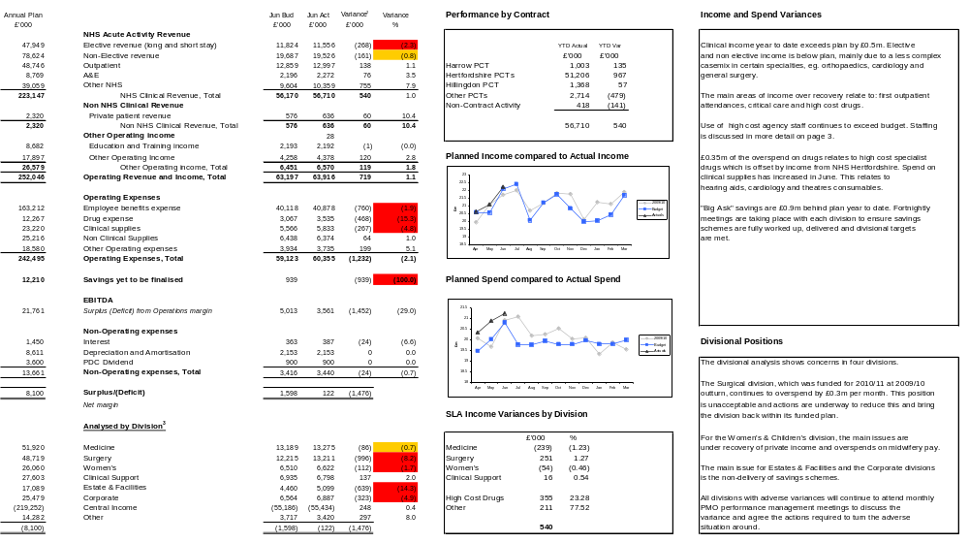

Delivery of Big Ask Savings

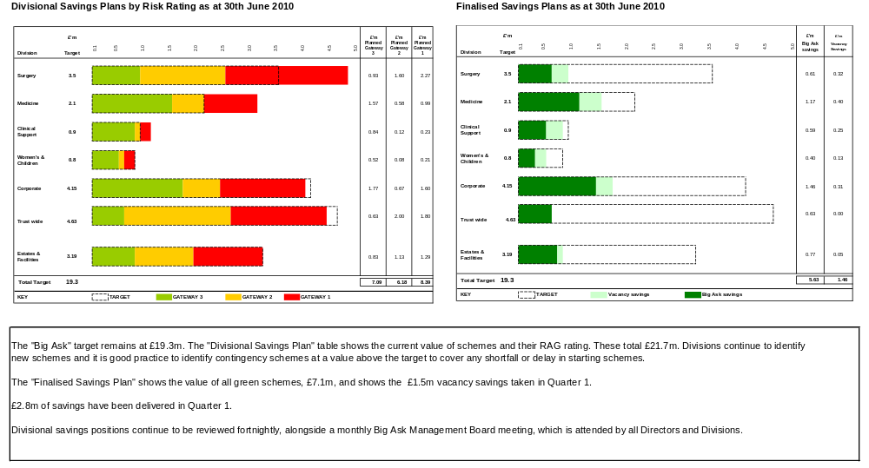

Activity

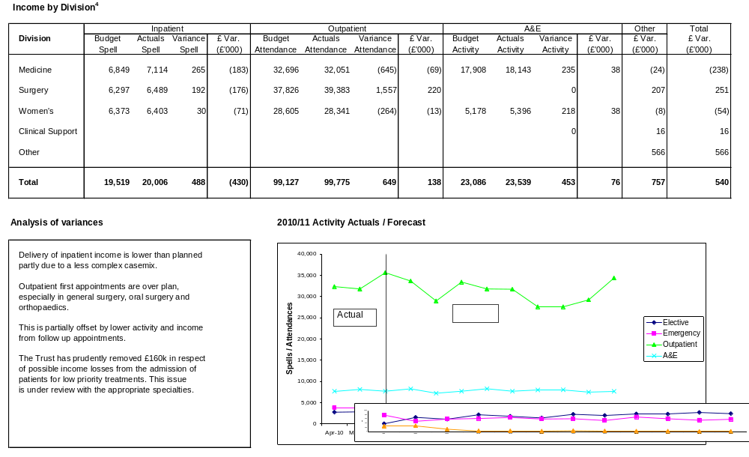

⁴As noted on page 2, SLA variances do not impact on divisional positions for budget monitoring purposes.
Workforce

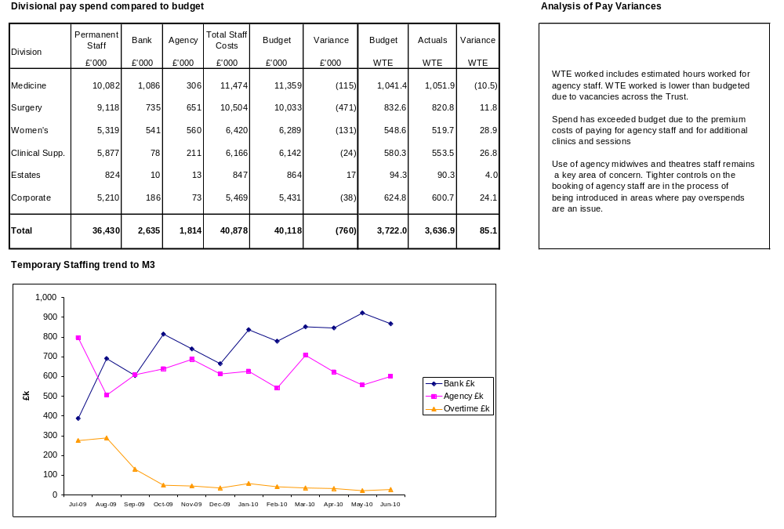
Cash and Capital Management

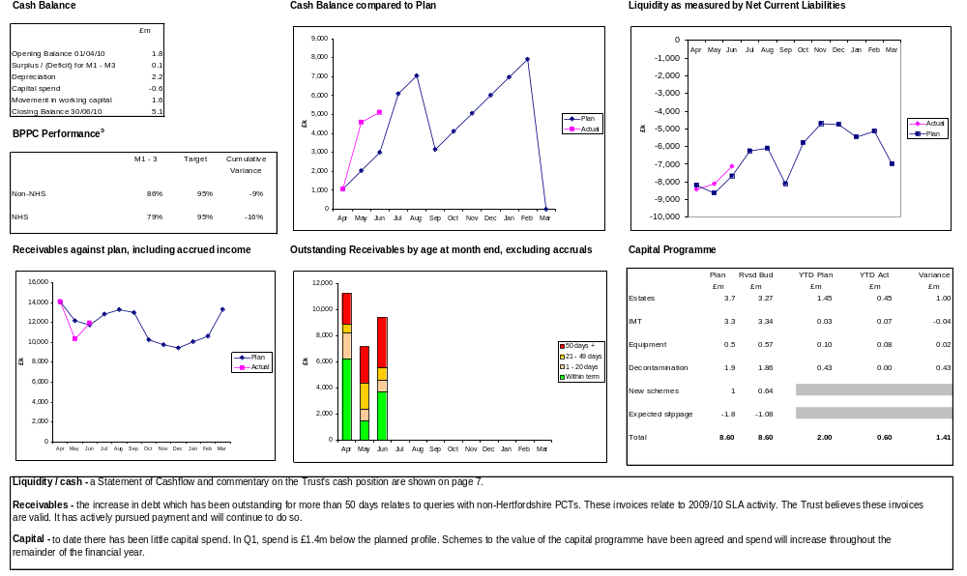
⁵Under the Better Practice Payment Code, the Trust has a duty to pay 95% of its invoices within 30 working days of receipt.

Statement of Cashflow

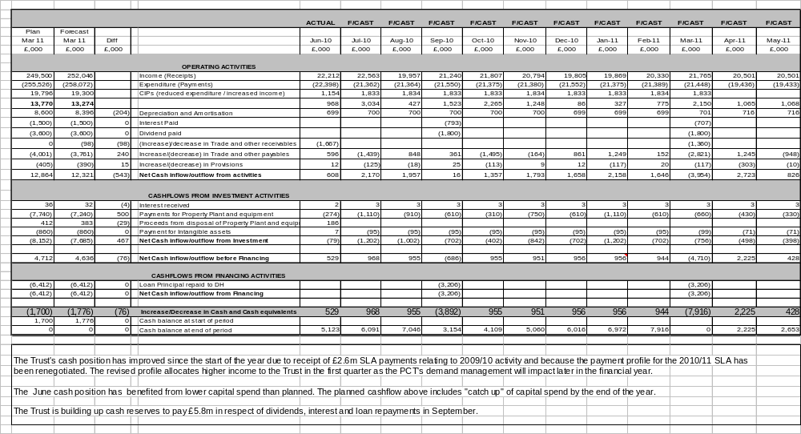

Statement of Financial Position (Balance Sheet)

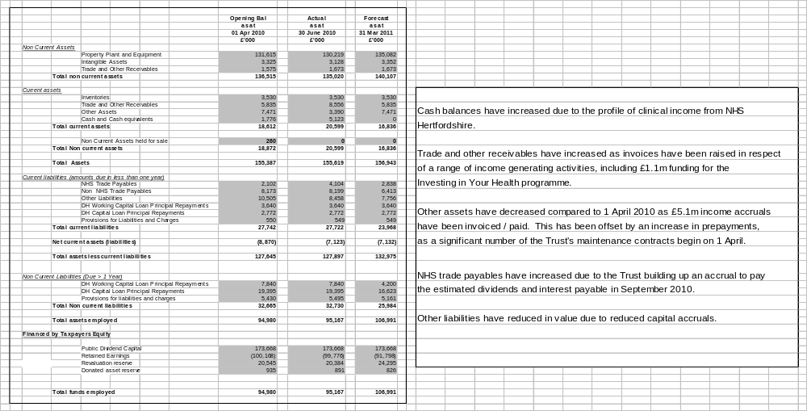

Financial Risk Ratings⁶

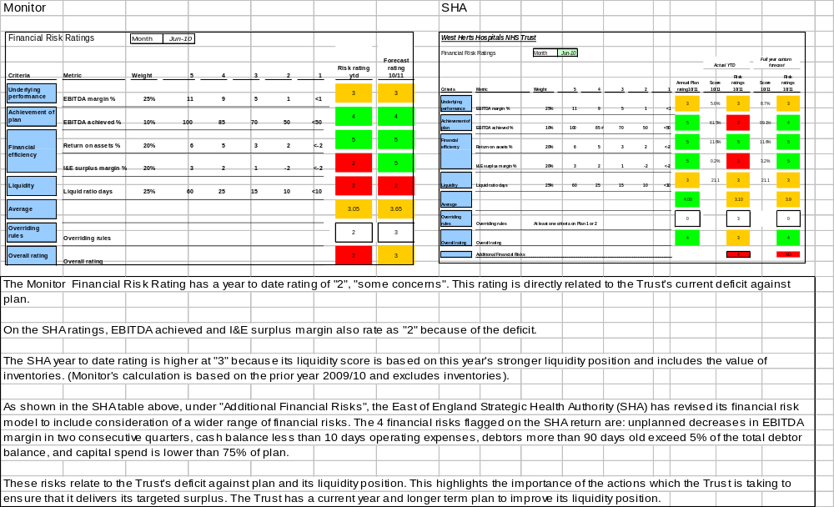

⁶Monitor calculations for liquidity and EBITDA achieved are based on 2009/10 performance. The SHA ratings are based on 2010/11 performance for all ratings. Monitor also exclude the value of inventories
(stock) from the liquidity calculation.

Red, greater than 1% variance from budget or greater than £0.5m negative variance; Amber negative variance of less than 1% or £0.5m. Variances less than £0.1m will not be highlighted as they are less material. ² A negative variance denotes an under recovery of income or an overspend compared to plan ³ Divisional variances exclude SLA income variances, which are shown under “Income”

